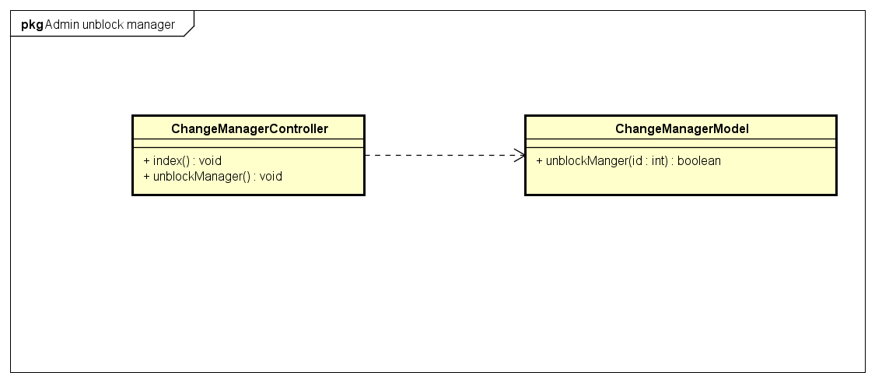

|  |  |
| --- | --- |
| **ChangeManagerControllers** | |
| **Physical address** | admin/application/controllers |
| **Base class** |  |
| **Attributes** | |
| N/A | |
| **Operations** | |
| Index() | |
| **Return Type** | void |
| **Parameters** | N/A |
| unblockManager() | |
| **Return Type** | void |
| **Parameters** | N/A |

|  |  |  |  |
| --- | --- | --- | --- |
| **ChangeManagerModel** | | | |
| **Physical address** | admin/application/models | | |
| **Base class** |  | | |
| **Attributes** | | | |
| N/A | | | |
| **Operations** | | | |
| unblockManager() | | | |
| **Return type** | boolean | | |
| **Parameters** | **Name** | **Type** | **Description** |
|  | id | int | The manager id to unblock |